**Project Deliverable #2: Finalizing Network Topology Design & Weekly Activities**

1. **Network Topology Design**:
   * The team initially designed the network topology using **draw.io**, focusing on configurations for both Site-to-Site and Client VPN. This initial design was shared with the project advisor, who approved the layout.
   * Following the approval, the finalized topology was created in **Cisco Packet Tracer**, incorporating essential components such as wireless devices (laptops and smartphones), access points, routers, and switches. This topology serves as the foundation for secure communication within the VPN infrastructure.
2. **Group Meeting 1**:
   * Conducted a meeting to share research updates regarding wireless communication. Team members discussed technical challenges encountered and collaborated to address them, fostering a supportive environment for problem-solving.
3. **Project Stakeholder Engagement Matrix**:
   * Delivered a lecture on stakeholder engagement and completed the Stakeholder Engagement Matrix. This document identifies key stakeholders, their roles, and their level of engagement, ensuring effective communication and alignment throughout the project.
4. **Professionalism in the Workplace Quiz**:
   * The team participated in a quiz designed to enhance professionalism in workplace communication. This interactive session reinforced key project management skills and encouraged effective communication strategies.
5. **Research on Wireless Communication**:
   * Conducted extensive research focused on secure data transmission, encryption protocols, and bandwidth management strategies. Insights gained during this research phase will inform the design and implementation of the VPN.
6. **Advisor Meeting**:
   * Met with the project advisor to review progress. Feedback was provided on the finalized network topology, with recommendations for adjustments to enhance bandwidth optimization and security protocols.
7. **Group Meeting 2**:
   * Reviewed the finalized topology in Cisco Packet Tracer, identifying any issues encountered with the simulation tool. Plans were made to address these challenges and prepare for subsequent testing and documentation phases.
8. **Live Presentations + Q&A**:
   * Presented the project’s progress to stakeholders, detailing the finalized network topology and the team’s roles. The presentation included discussions on challenges faced, with positive feedback received along with suggestions for future improvements.
9. **Progress Report & Activity Log**:
   * Compiled and submitted the Week 4 progress report, summarizing all completed tasks, challenges addressed, and contributions from each team member.

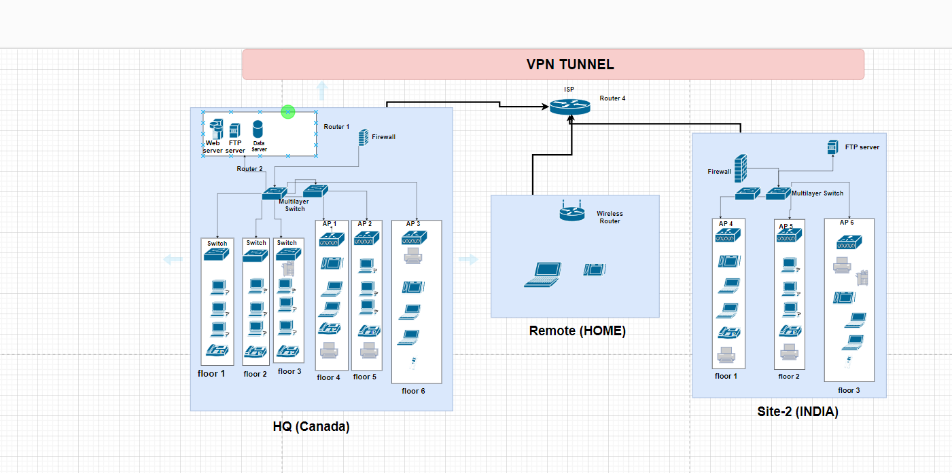

**Initial Topology**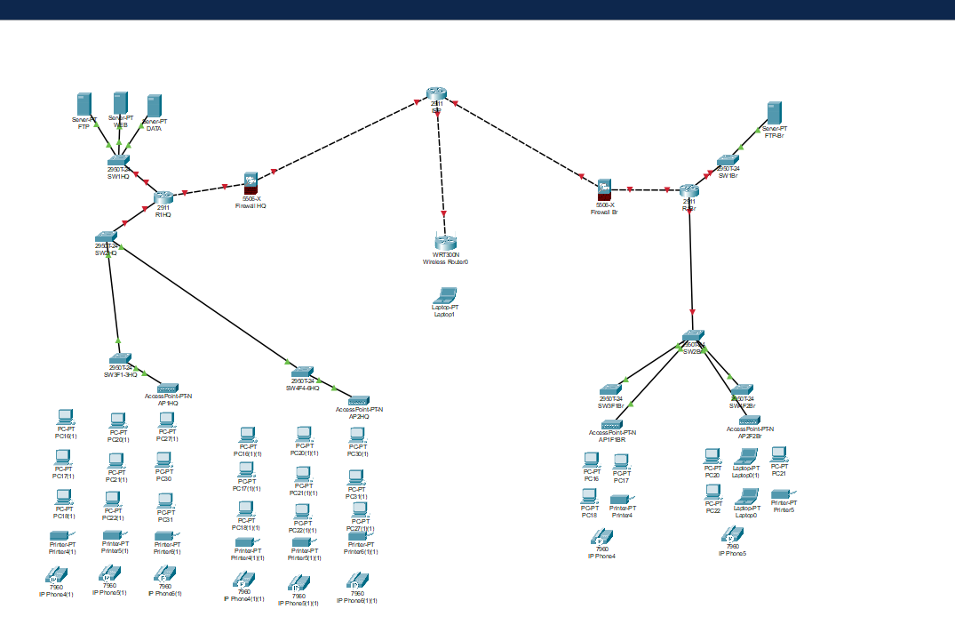

**Topology in Packet Tracer**

**Next Steps for Week 5**

1. **VPN Configuration:**
   * Configure Site-to-Site and Client VPN tunnels using Cisco routers.
   * Implement encryption protocols (e.g., IPSec or SSL/TLS).
2. **Initial Testing:**
   * Conduct initial testing of the VPN configurations to ensure functionality and security.